PRESS RELEASE

COMMUNICATIONS AND MEDIA TEAM OF THE 2023 ASEAN SUMMIT

No.51/SP/TKM-ASEAN2023/ENG/5/2023

Communications and Informatics Minister Invites Media Disseminate Information on 42nd ASEAN Summit in Labuan Bajo.

West Manggarai, 8 May 2023 – Indonesia holds the Chairmanship of ASEAN 2023, and the 42nd ASEAN Summit has started from 8 May to end on 11 May 2023 in Labuan Bajo, West Manggarai, East Nusa Tenggara (NTT). Meanwhile, in September 2023, Jakarta will host the 43rd Summit, continuing the success of Indonesian Chairmanship.

Johnny G. Plate, Minister of Communications and Informatics, also invited journalists and the media to disseminate information regarding ASEAN Chairmanship to the community.

"We anticipate great enthusiasm of media participation. Hopefully, the outcomes of the 42nd ASEAN Summit, which will be chaired by the President, will be disseminated to the entire community immediately and correctly. That way, the public is aware of all the pillars expected and produced," he stated after evaluating the Media Center of the 42nd ASEAN Summit 2023 at the Bintang Flores Hotel in Labuan Bajo, West Manggarai, East Nusa Tenggara, on Monday (08 May).

The Minister stated that the media center has adequate digital and telecommunications infrastructure.

"The internet is quick, high-speed internet. There are fiber optic services here, as well as 4G and 5G infrastructure," he explained.

Minister Johnny stated that cellular operator partners, Telkomsel, have also established a large number of Base Transceiver Stations (BTS) and have even prepared BTS Combat.

"As long as nothing goes unexpectedly, hopefully the service will be excellent," he said.

The Minister of Communications and Informatics stressed that the support of ICT infrastructure facilities in the media center is expected to assist media crews in contributing to the success of the ASEAN Summit.

As of 14:47 local center Indonesian time today, a total of 448 media have been registered and verified by the committee for the 42nd ASEAN Summit.

Johnny explained that there are 76 Indonesia-based foreign media, 45 foreign media, 152 national media, 122 DEOs, and 53 photo+broadcast hosts.

The Minister of Communications and Informatics also explained that President Joko “Jokowi” Widodo will visit the media center on Tuesday (09 May) to observe preparations for the ASEAN Summit.

"In addition, the Head of State will also hold an official press conference on 13 May 2023. For this reason, the media will hopefully receive all deliverables produced during the two-day Summit," he said. (Kominfo/TR/Elvira/SC)

***

For more information, please contact:

Director General of Public Information and Communications of the Ministry of Communications and Informatics – Usman Kansong (0816785320).

Get other information at http://asean2023.id, https://infopublik.id/kategori/asean-2023, and https://indonesia.go.id/kategori/ragam-asean-2023

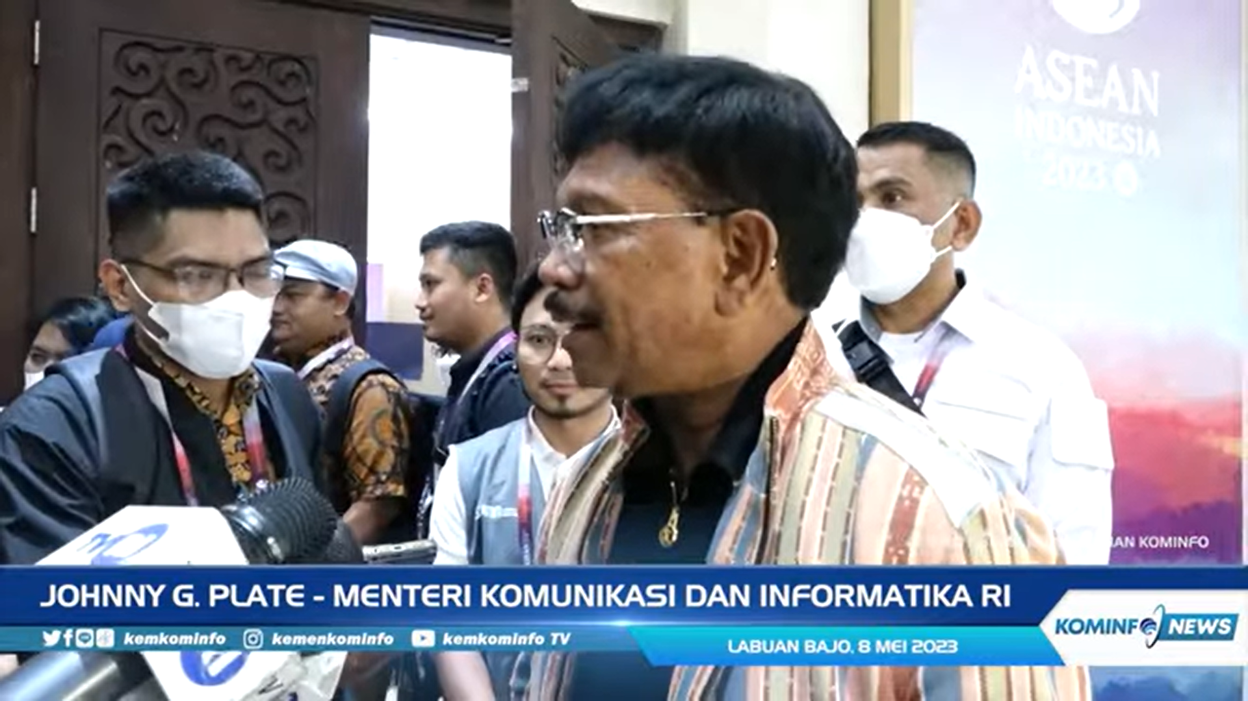

Minister of Communications and Informatics Johnny G. Plate after visiting the Media Center of the 42nd ASEAN Summit 2023 at the Bintang Flores Hotel, Labuan Bajo, West Manggarai, East Nusa Tenggara, Monday (08 May 2023). He also invites journalists and the media to disseminate information about ASEAN Chairmanship to the community.

